Interface Documentation

I) In general folder

All HTML files use the Bootstrap grid system (https://getbootstrap.com/docs/4.0/layout/grid/), to position and to size the component and are based on a Bootstrap template (see below).

I.1 index.html

Landing page, simple HTML page. This page is a modification of a Bootstrap template (https://startbootstrap.com/template-overviews/agency/).
Links:
- Top navigation bar, get to About, Upload, Query page.

I.2 upload.html

Simple HTML page, to be done. At the moment, it has placeholder for the upload feature.

Links:
- Top navigation bar, get to About, Landing, Query page.

I.3 about.html

Simple HTML page to display informartion about the project. Some information are still relevant, some might have to be changed.

Links:
- Top navigation bar, get to Upload, Landing, Query page.

I.4 query.html

HTML page that presents the interface for the General query search. It is on this page that the user input is collected, along with the chosen category.

It is also where more fields are placed, with dynamic addition of HTML elements, with JavaScript.

Links:
- Top navigation bar, get to Upload, Landing, About page.
- Functional link to the query_page.js.

I.5 advanced.html

HTML page that presents the interface for the Advanced query search. It is on this page that the user input is collected, along with the chosen category. The difference between the query.html and the advanced.html is that the advanced categories are divided into three types: project, diagram, documentation.

It is also where more fields are placed, with dynamic addition of HTML elements for each category, with JavaScript.

Links:
- Top navigation bar, get to Upload, landing, About page.
- Functional link to the advanced_query_page.js.
II) In "CSS" folder

II.1 about.css

CSS file used for the about page, as a test, initially, then modified for the upload page.

Links:
- About page
- Upload page

III) In "js" folder

III.1 query_page.js

JavaScript file linked ONLY to the query page, not the advanced. Provides the functions to add fields to the HTML page and retrieve the information from it.
Functions:

- add_field(div_name, input_type), add an additional user input field to the page. The "input_type" is either a filter or an input_field, and is added to the "div_name" div.

- start_query(), function lauched when the user clicks the "Search" button or presses enter. Creates an object containing the user inputs, the category of that input and the AND/OR status, if there are additional fields. Each data is stored in an array, the index value is shared for all arrays, meaning that the category at index 0 will be correspondinf to the user input at index 0.
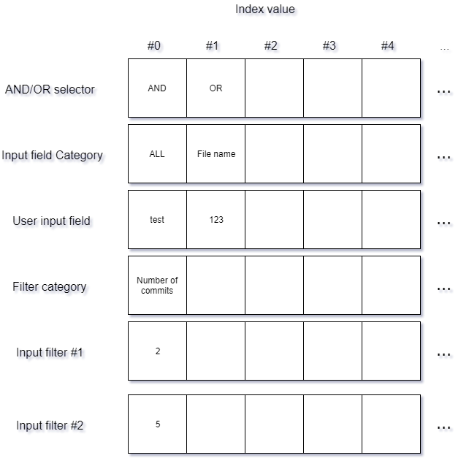
Then, gets all the information from the HTML query page to fill the object.

AND/OR status are retrieved with the HTML class name "current_andor".
Categories are retrieved with the HTML class name "current_text".
User inputs are retrieved with the HTML name "user_input_field".
There are no filters on this page.

Then, translate the object in JSON format, with the function JSON.stringify, to be transfered to the query_result.php.

Finally, transmit the object to the php file.

- remove_class(div_id), removes all the content of the "div_id" div. Used when the user deletes one field.

- EventListener, calls the start_query function when the user presses Enter.

Links:
- query_page.html
- query_result.php

III.2 advanced_query_page.js

JavaScript file linked ONLY to the advanced query page, not the general query. Provides the functions to add fields to the HTML page and retrieve the information from it.
Functions:

- start_query(), function that has the same behaviour as the start_query function in query_page.js, except that this can generate filters as well as input fields.

- EventListener, calls the start_query function when the user presses Enter.

- remove_class(div_id), removes all the content of the "div_id" div. Used when the user deletes one field.

- show_class(), displays the class level research.

- plusminus(change_button), changes the text of the button "change_button" from a plus to a minus and vice versa, depending if the zone is expanded or not. Zones are project, diagram and documentation.

- add_field(div_id), add an additional user input field to the page. It can be a filter. The created field is added to the div having "div_id" for id. A different type of input is created for each possible result (project, diagram, class diagram, doucmentation) because the categories, next to the user input zone are not the same.

Filters are retrieved with two HTML elements, corresponding to the upper and lower threshold of the filter. They are retrieved from the HTML elements having "filter_1" and "filter_2" as name attribute.
Filter categories are retrieved with the HTML class name "current_filter".

- switch_input_filter(div_name,id_name), changes the input zone to a filter input zone and vice versa when the user changes the category selected. It also changes the name attribute of the category, from "current_text" for an input zone to "current_filter" for a filter and vice versa. The selected category is retrieves thanks to the "div_name", and the zone to change is retrieves thanks to the "id_name", id attribute of the zone.

Links:
- advanced_ query_page.html
- advanced_query_result.php

III.3 results.js

JavaScript files linked with both the query_result.php and the advanced_query_result.php. Creates a new instance of a result template for each result and switched between the card and the list view. It is also used when sorting the results.
Functions:
- add_field(), switchs the display of the results to the card view.

- switch_view(display), function called directly after the query is done. It builds the HTML page with templates according to the results from the PHP file. This function switchs to the list view. Initially, the card view was default and the list the other one, hence the name. The "display" variable is the type of results i.e. project or diagram.

- compare(x,y), is a sorting function, used in conjonction with the "sort" function in the sorting_function below. This is due to JavaScript behaviour: it needs an indication on how to sort an array, even when using the "sort" built-in function. The same goes for the 2 following functions. This functions sorts the templates in increasing or decreasing order, for numbers only.

- alphabet_sorting(x,y), sorts the templates if the selected criteria is a word containing letters, and not numbers.

- project_number_sorting(x,y), sorts the templates if the criteria selected is the project name. It removes the project number before sorting.

- sorting_function(selected_option), gets the "selected_option", the criteria by which the results have to be sorted and calls one of the sorting functions to execute it. It also regenenerates the HTML page if the selected_value is the default one.
This function gets all the generated templates by their id, which is "template_number"+ the number of that template, and the selected option value for each template, in an object containing 2 arrays, one for the templates, and one for the values to be sorted. It then sorts the values to be sorted and displays the templates according to this sorting. The same index value principle from the JSON object passing data to the PHP is applied: one template is always linked to its own value to be sorted, even after the array has been sorted.

- sort_order(), switchs the text on the "Increasing or Decreasing" button, from "Increasing" to "Decreasing" and vice versa. Also changes a variable in the JavaScript file, "increasing", form true to false, depending on the sorting order.
Links:
- query_result.php
- advanced_query_result.php
IV) In "php" folder

IV.1 query_result.php

Those two files serve two objectives: first, they hold the templates that will be filled with the information in the result page and, also, it is those pages that build and execute the query line.

The HTML elements are the base of all pages (Bootstrap template modified to suit the website, navigation bar, footer), and the templates to be filled. In addition, there is also the "div" elements which will be filled with the templates.

The PHP part has three roles:

- Initializes the database connection, basic lines to initialize it, this is where the login will be taken into account, with the username and password

- Builds the query line. All query lines starts the same:

SELECT * FROM repos INNER JOIN umlfiles ON repos.id = umlfiles.repo_id WHERE

They are, then, modified depending on the category and the user input.

The query line is a string that is modified to fit the user criteria, with categories and AND/OR added at the end of the line.

- Gives the results to the JavaScript file, to build the result page. Once the result is known, the PHP file encodes it to JSON, and pass it to the JavaScript file.

IV.2 advanced_query_result.php

This page is essentialy the same as the query_result.php. The difference is on the query building, because the category are different. Everything else is the same.

One point to notice, however, is that there are filters on this page, as well as user inputs. The way the query line is built is that the user input is places before the filter inside the query line, always in this order.

The following diagram shows the interactions between the files.
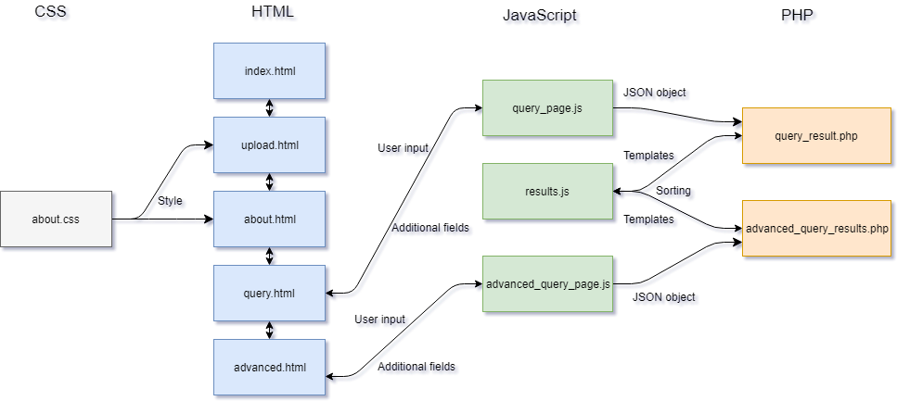
-login folder: this folder was used for testing, when the upload feature was first discused. The codes in it can functional, but it has to be tested before use.

- All other files and folders, no matter the language come from the Bootstrap template, they are used for certain pre-set functionlities, like the navigation bar, or the design of the buttons.

